МДК 01.03 «Разработка мобильных приложений»

Практическая работа №2

Учебная группа 32.1Исд

Студент Данилин Николай Юрьевич

# Код программного приложения

Листинг 1.

|  |
| --- |
| MainViewModel  using Danilin_Praktika2.Contexts;  using Danilin_Praktika2.Models;  using System;  using System.Collections;  using System.Collections.Generic;  using System.ComponentModel;  using System.Linq;  using System.Runtime.CompilerServices;  using System.Text;  using System.Threading.Tasks;  namespace Danilin_Praktika2.ViewModels  {  public class MainViewModel: INotifyPropertyChanged  {  public event PropertyChangedEventHandler? PropertyChanged;  public void OnPropertyChanged([CallerMemberName] string name = "")  {  PropertyChanged?.Invoke(this, new PropertyChangedEventArgs(name));  }  private IEnumerable<User> _users;  public IEnumerable<User> USERS  {  get  {  return _users;  }  set  {  _users = value;  OnPropertyChanged();  }  }  private void GetUser()  {  using (var context = new UserContext())  {  USERS = context.Users.ToList();  }  }  public MainViewModel()  {  GetUser();  }  }  } |
| USER CONTEXT |
| using Danilin_Praktika2.Models;  using Microsoft.EntityFrameworkCore;  using System;  using System.Collections.Generic;  using System.Linq;  using System.Text;  using System.Threading.Tasks;  namespace Danilin_Praktika2.Contexts  {  public class UserContext : DbContext  {  public DbSet<User> Users { get; set; }  protected override void OnConfiguring(DbContextOptionsBuilder optionsBuilder)  {  optionsBuilder.UseSqlServer("Server=localhost\\SQLEXPRESS;Database=Danilin;Trusted_Connection=True;TrustServerCertificate=True");  }  }  }  USER |
| using System;  using System.Collections.Generic;  using System.Linq;  using System.Text;  using System.Threading.Tasks;  namespace Danilin_Praktika2.Models  {  public class User  {  public int userId { get; set; }  public string login { get; set; }  public string password { get; set; }  public bool isAdmin { get; set; }  }  }  XAML  <Window x:Class="Danilin_Praktika2.MainWindow"  xmlns="http://schemas.microsoft.com/winfx/2006/xaml/presentation"  xmlns:x="http://schemas.microsoft.com/winfx/2006/xaml"  xmlns:d="http://schemas.microsoft.com/expression/blend/2008"  xmlns:mc="http://schemas.openxmlformats.org/markup-compatibility/2006"  xmlns:vm="clr-namespace:Danilin_Praktika2.ViewModels"  xmlns:local="clr-namespace:Danilin_Praktika2"  mc:Ignorable="d"  Title="MainWindow" Height="450" Width="800">  <Window.DataContext>  <vm:MainViewModel/>  </Window.DataContext>  <StackPanel>  <Label Content="{Binding USER.login}"></Label>  <ListView ItemsSource="{Binding USERS}">  <ListView.View>  <GridView>  <GridViewColumn Header="userId" DisplayMemberBinding="{Binding userId}"></GridViewColumn>  <GridViewColumn Header="login" DisplayMemberBinding="{Binding login}"></GridViewColumn>  <GridViewColumn Header="password" DisplayMemberBinding="{Binding password}"></GridViewColumn>  <GridViewColumn Header="isAdmin" DisplayMemberBinding="{Binding isAdmin}"></GridViewColumn>  </GridView>  </ListView.View>  </ListView>  </StackPanel>  </Window> |

# Демонстрация работы приложения

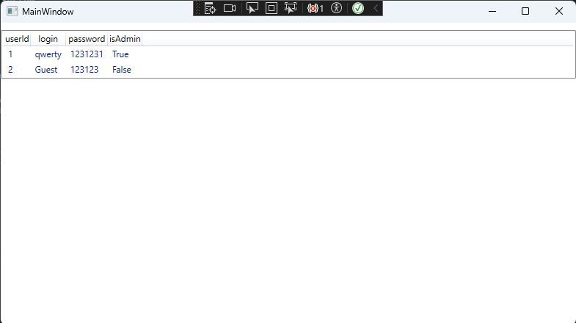

Рисунок 1. Вывод таблицы Admin из SQL в WPF